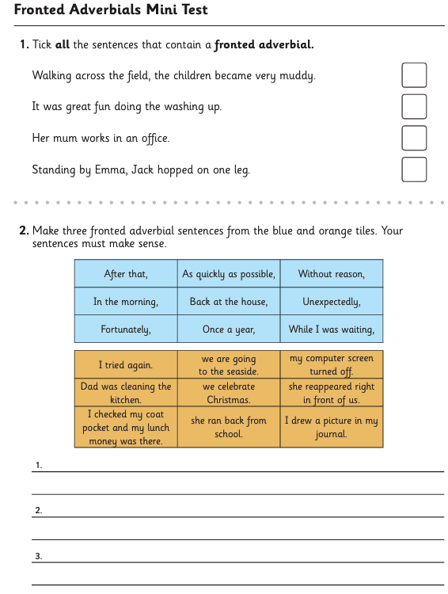
Week commencing – 5.10.2026

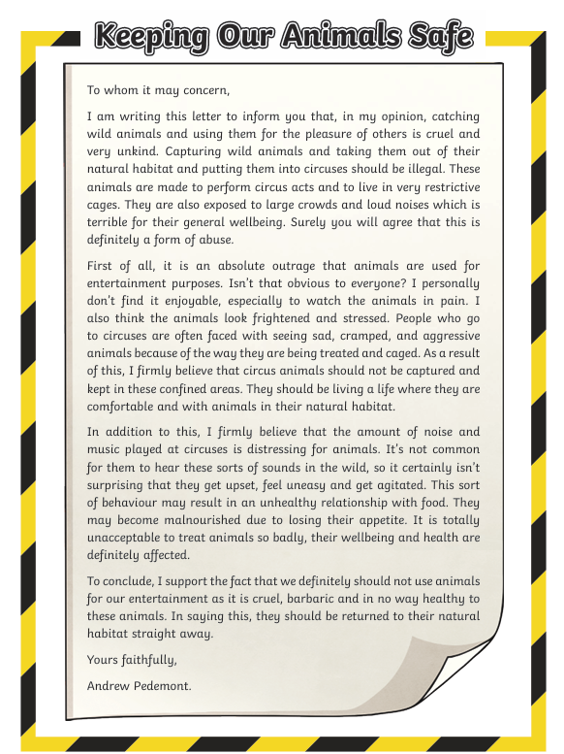
Week commencing 12.10.2026
1 – what is the topic of this text?
2 – is the author for or against this topic? How do you know?
3 – What reasons does the author give to support their opinion?
4 – who could the author be writing this text to?
5 – list two reasons that support the author’s second reason that the amount of noise and music played at circuses is distressing for animals.
6 – do you agree that animals should not be used for entertainment? Why or why not?

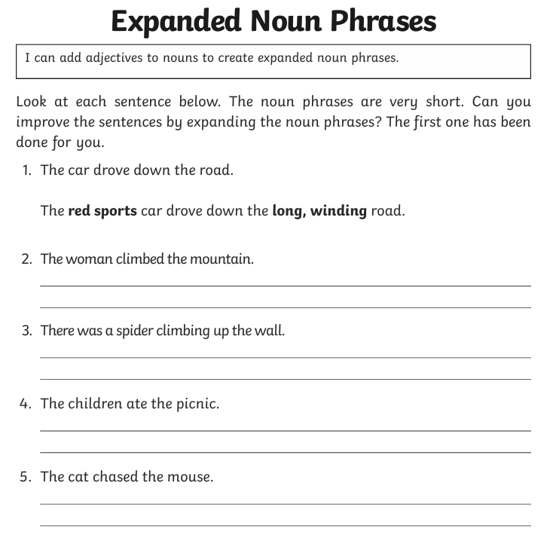
Week commencing – 18.10.2026

